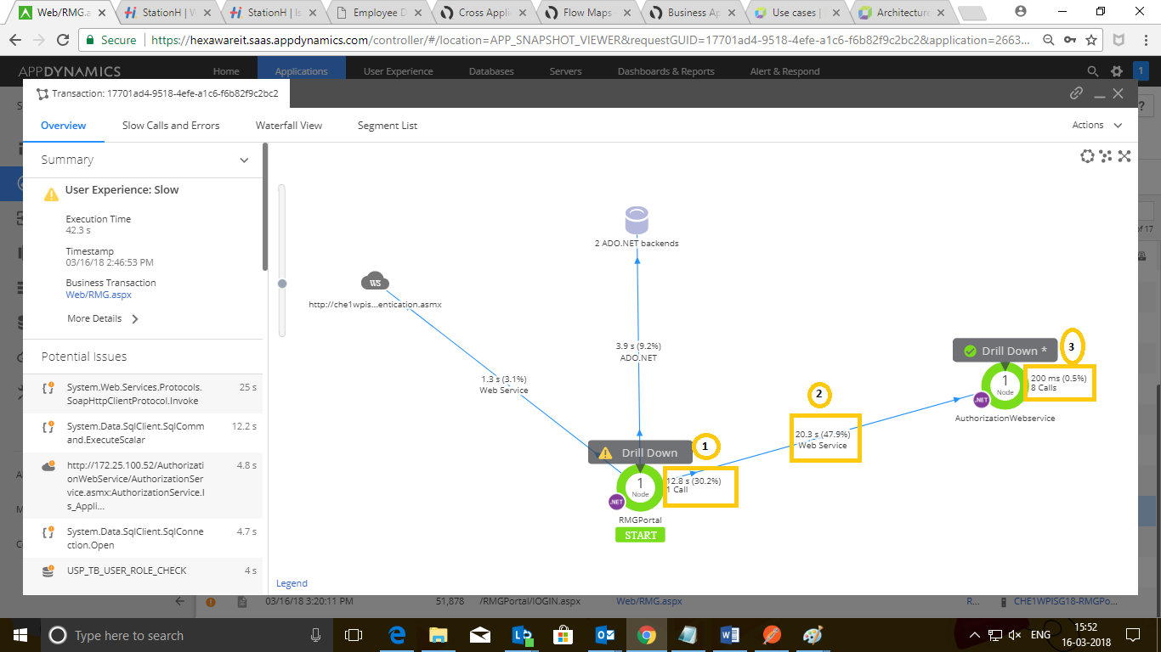
I’ve query with the understanding the metrics on this above flow map.
1). In above snapshot (mark 1), 12.8 S (1 call) is this time taken by that node RMGPortal to make any outgoing call or it’s a call to that node itself?
2). (Mark 2) 20.3 Seconds I believe that’s time took for a call from node RMG Portal to Authorisation web service. Pls correct me if I’m wrong.
3). Same like in (mark 3) it shows 200 MS & 8 Calls , could someone tell what’s that denotes .?

